Name: Lujain Zia
Roll no: 2023-BSE-034
Date: January 15, 2026

Lab 14
Task 0 Lab Setup (Codespace & GH CLI)
Create Codespace & connect:
# Fork the repository
# Go to: https://github.com/WaqasSaleem97/terraform_machine.git
# Click Fork button
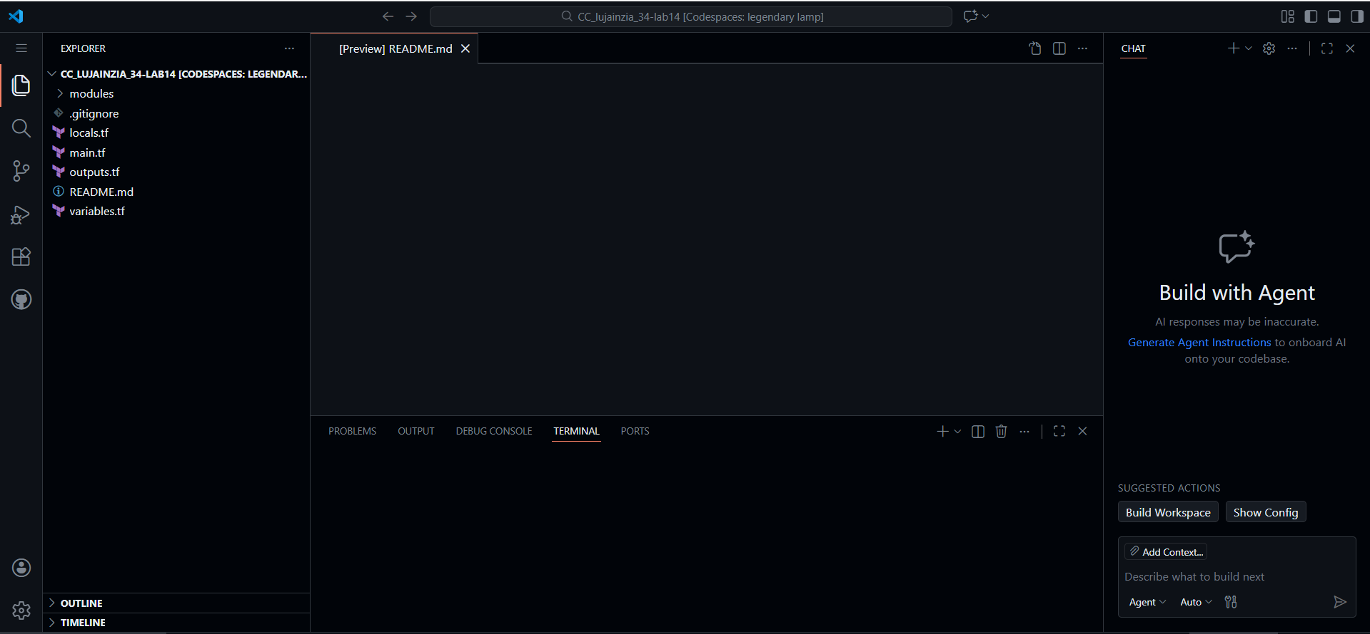
Verify environment:
aws --version
terraform --version
ansible --version || echo "ansible not yet installed"
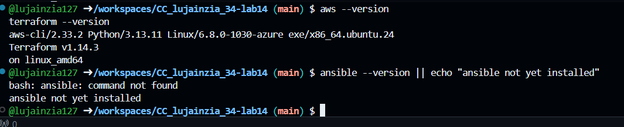
Configure AWS:
aws sts get-caller-identity
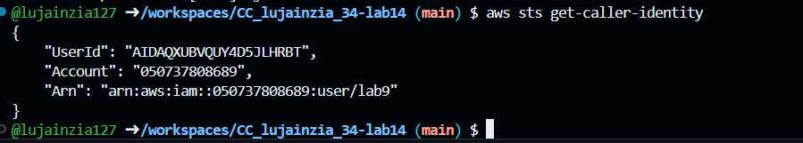
Task 1 Generate ssh key and Initial Terraform apply

Check SSH directory & generate key:
ls ~/.ssh
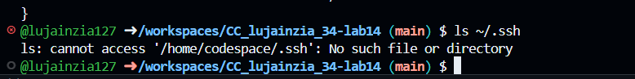
ssh-keygen -t ed25519 -f ~/.ssh/id_ed25519 -N ""
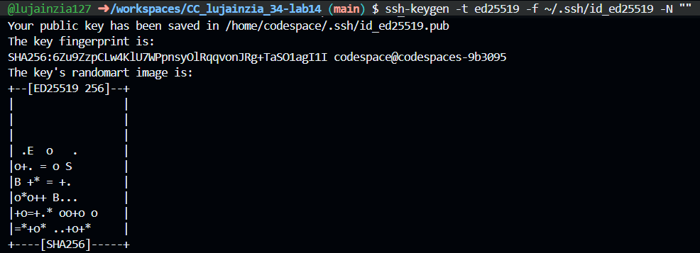
ls -la ~/.ssh
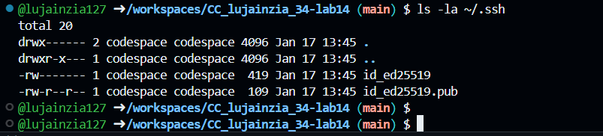
Create terraform.tfvars:
cd /workspaces/terraform_machine
touch terraform.tfvars
ls -la terraform.tfvars
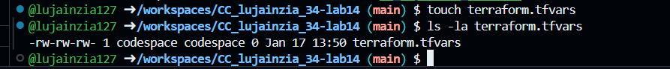
Add content to terraform.tfvars:
vpc_cidr_block = "10.0.0.0/16"
subnet_cidr_block = "10.0.10.0/24"
availability_zone = "me-central-1a"
env_prefix = "dev"
instance_type = "t3.micro"
public_key = "~/.ssh/id_ed25519.pub"
private_key = "~/.ssh/id_ed25519"
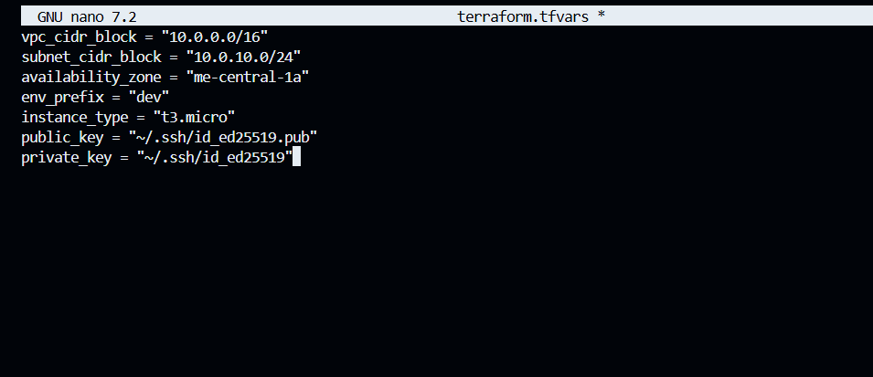
Initialize Terraform:
terraform init
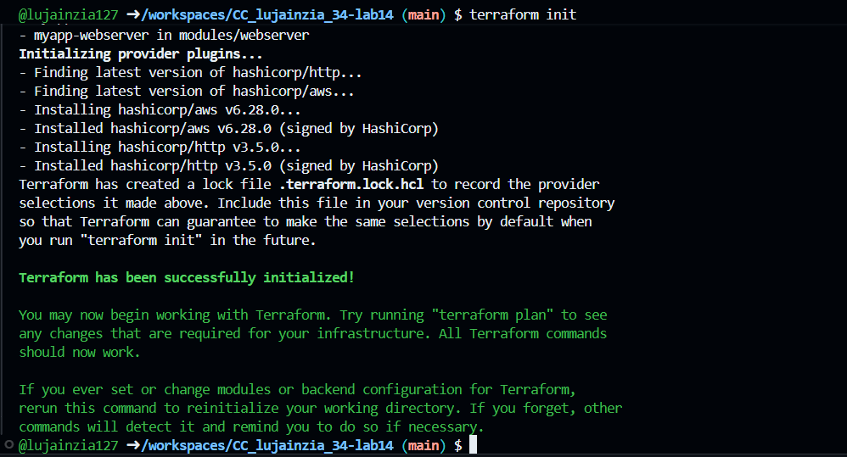
Apply Terraform:
terraform apply -auto-approve
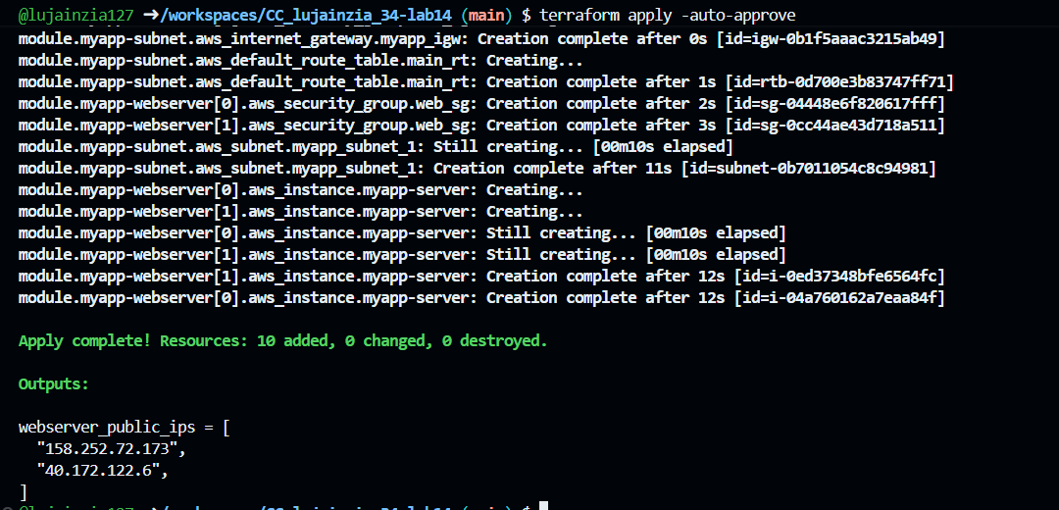
Check outputs:
terraform output
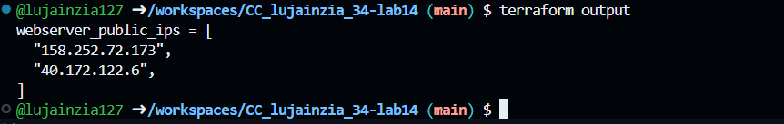
Task 2 Static Ansible inventory with two EC2 instances

Install Ansible:
pipx install ansible-core
ansible --version
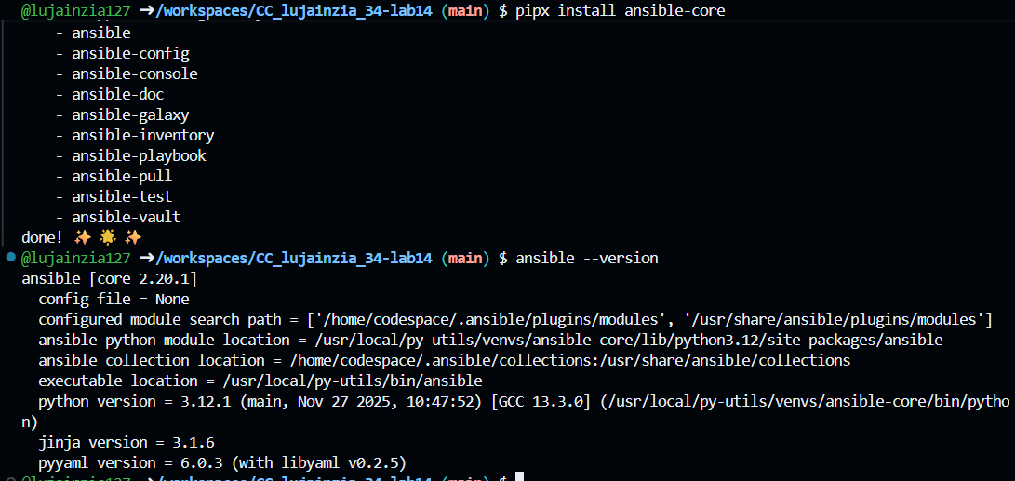
Get instance IPs:
terraform output
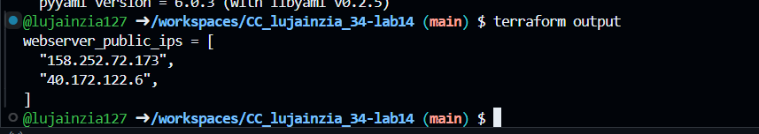
Create inventory file:
touch hosts
ls -la hosts
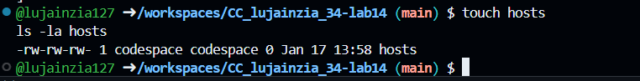

Add hosts (replace IPs):
<public-ip-ec2> ansible_user=ec2-user ansible_ssh_private_key_file=~/.ssh/id_ed25519
<public-ip-ec2> ansible_user=ec2-user ansible_ssh_private_key_file=~/.ssh/id_ed25519
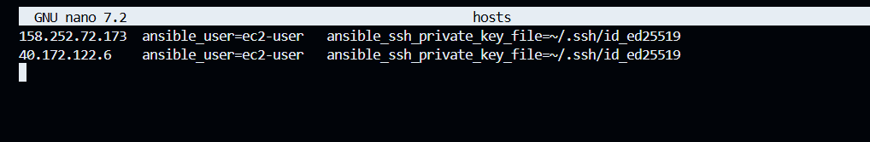
Test connectivity:
ansible all -i hosts -m ping
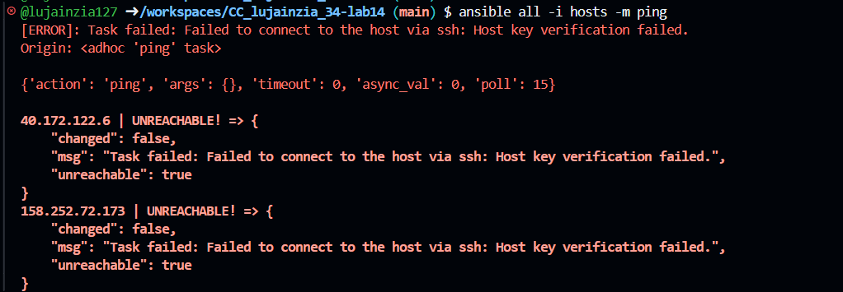
Add common args:
# Add to each host line:
ansible_ssh_common_args='-o StrictHostKeyChecking=no'
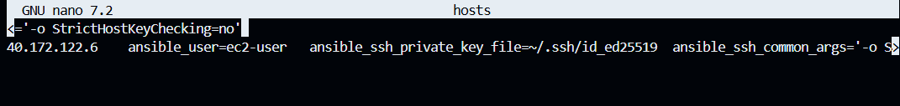
Retry ping:
ansible all -i hosts -m ping
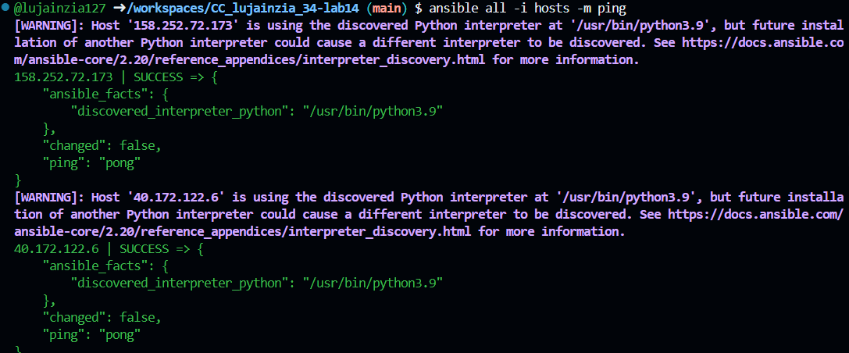
Task 3 Scale to three instances & group-based inventory

Update main.tf:
# Change count to 3 in webserver module
count = 3
instance_suffix = count.index
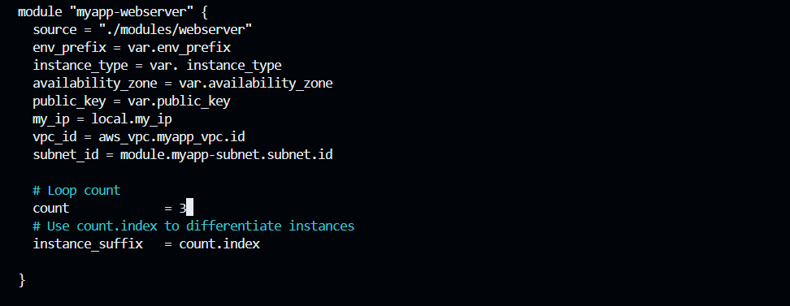
Update outputs.tf:
output "ec2_public_ips" {
value = module.myapp-webserver[*].instance.public_ip
}
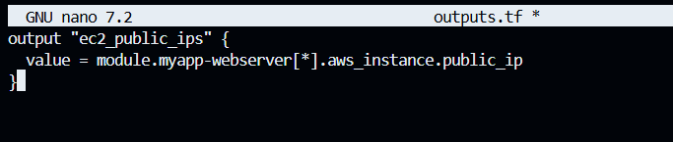
Apply changes:
terraform apply -auto-approve
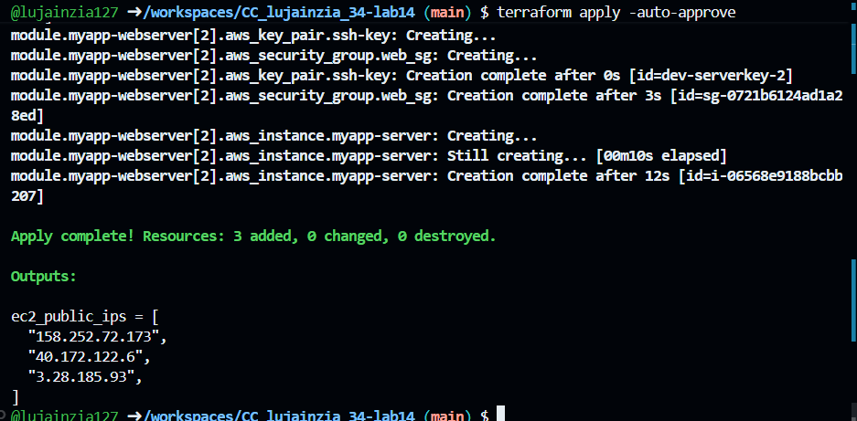
Verify 3 instances:
terraform output
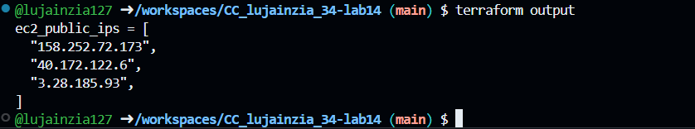
Update hosts with groups:
[webservers]
<ip-1> ansible_user=ec2-user ansible_ssh_private_key_file=~/.ssh/id_ed25519
<ip-2> ansible_user=ec2-user ansible_ssh_private_key_file=~/.ssh/id_ed25519
<ip-3> ansible_user=ec2-user ansible_ssh_private_key_file=~/.ssh/id_ed25519

[webservers:vars]
ansible_ssh_common_args='-o StrictHostKeyChecking=no'
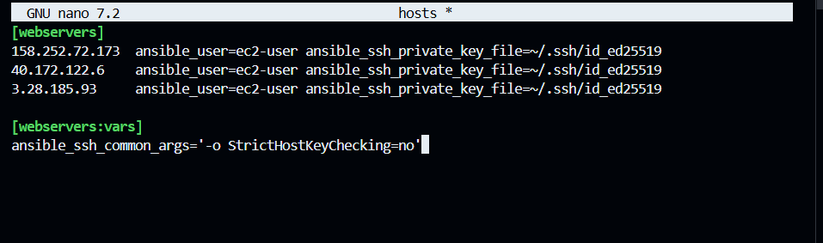
Test group:
ansible webservers -i hosts -m ping
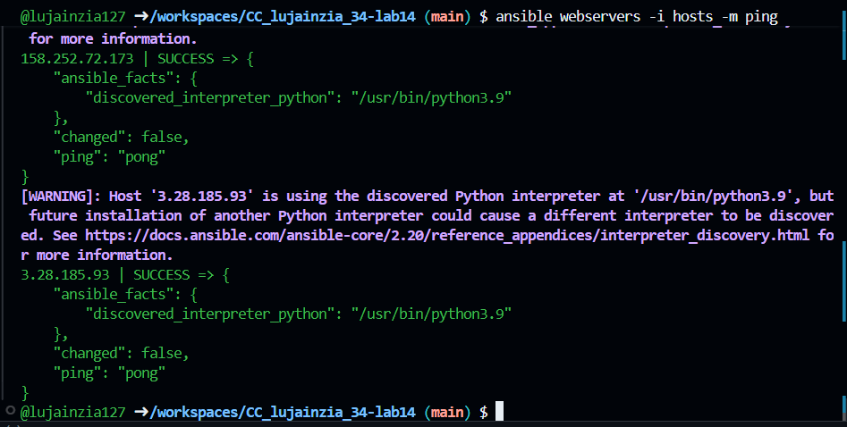
Task 4 Global ansible.cfg & first nginx playbook

Create global config:
touch ~/.ansible.cfg
# Add content:
[defaults]
inventory = ~/hosts
host_key_checking = False
remote_user = ec2-user
private_key_file = ~/.ssh/id_ed25519
Screenshot: task4_ansible_cfg_global.png
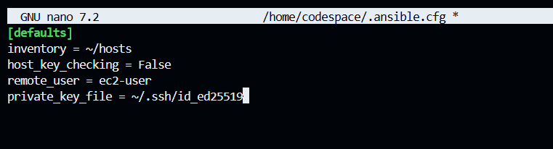
Create nginx playbook:
touch my-playbook.yaml
Screenshot: task4_nginx_playbook.png
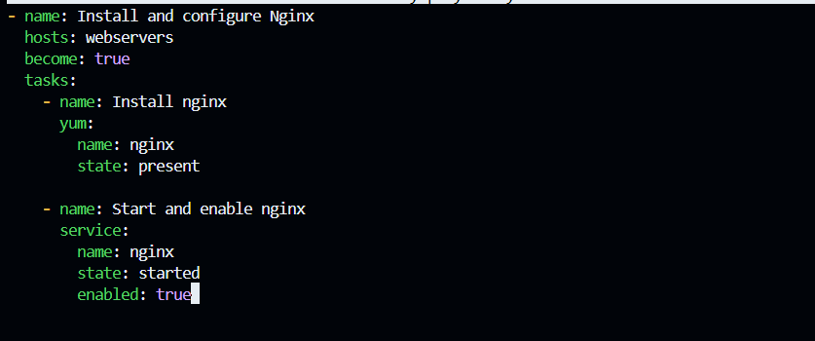
Run playbook:
ansible-playbook my-playbook.yaml
Screenshot: task4_ansible_playbook_run.png
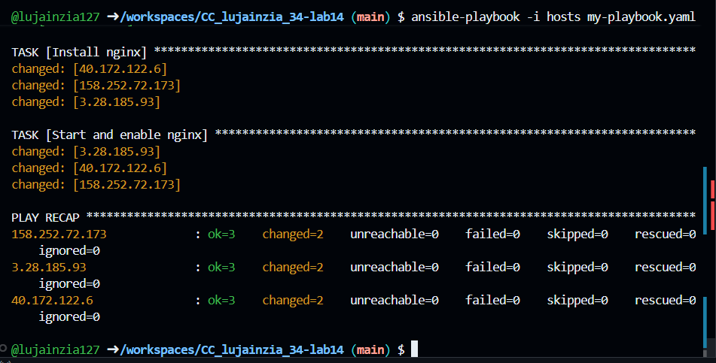
Check nginx status:
ansible webservers -m shell -a 'systemctl status nginx'
Screenshot: task4_nginx_status.png
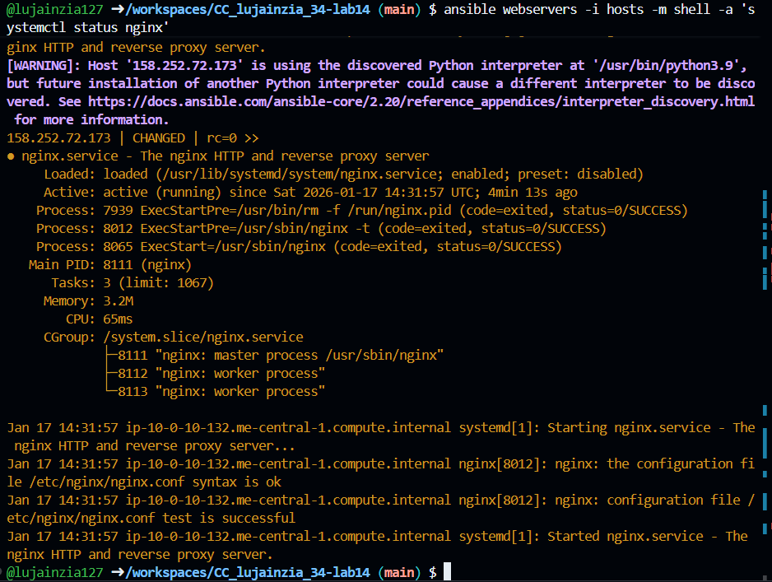
Test in browser:
# Open http://<instance-ip>
Screenshot: task4_nginx_browser.png
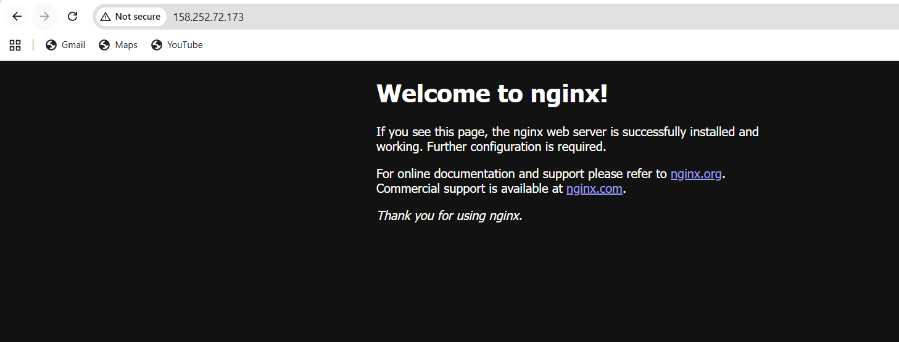
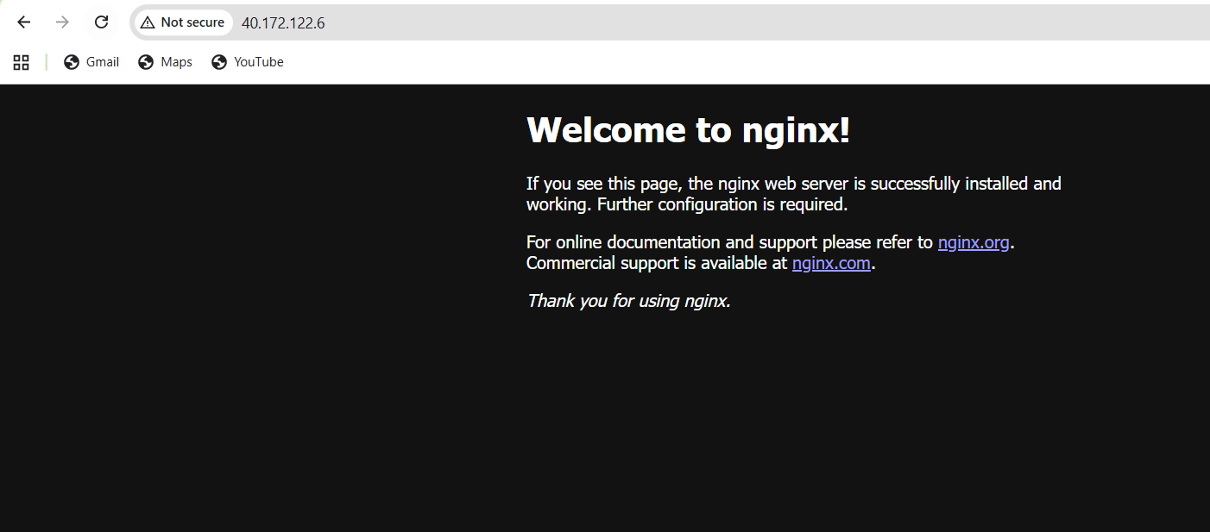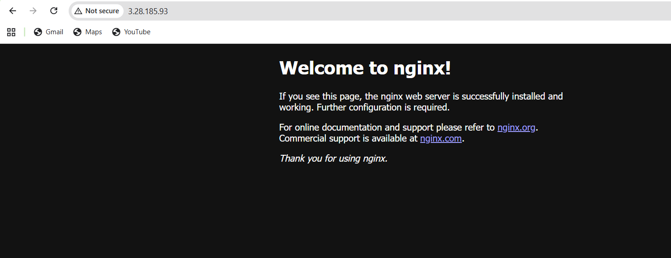

Task 5 Single nginx target group & HTTPS prerequisites

Create nginx group:
[nginx]
<ip-1> ansible_user=ec2-user ansible_ssh_private_key_file=~/.ssh/id_ed25519

[nginx:vars]
ansible_ssh_common_args='-o StrictHostKeyChecking=no'
Screenshot: task5_hosts_nginx_group.png
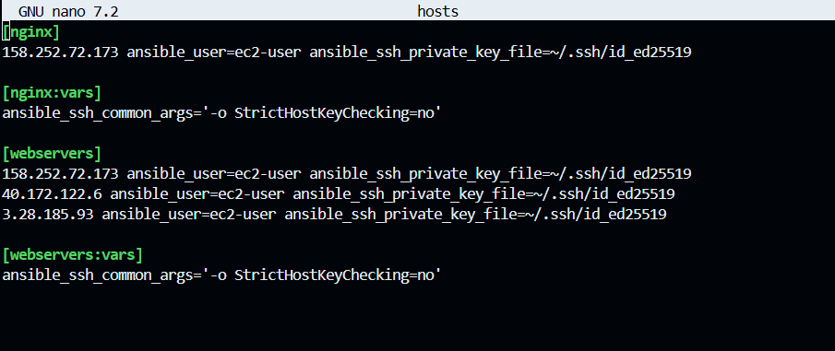
Create project ansible.cfg:
mkdir -p ansible
touch ansible/ansible.cfg
Screenshot: task5_ansible_cfg_project.png
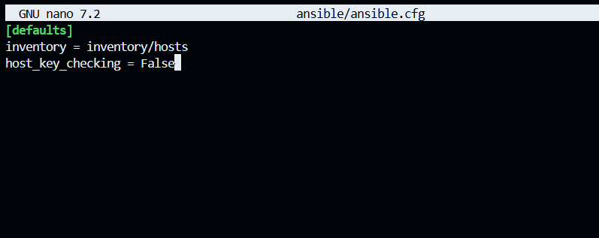
Move inventory:
mkdir -p ansible/inventory
mv hosts ansible/inventory/
Screenshot: task5_inventory_moved.png
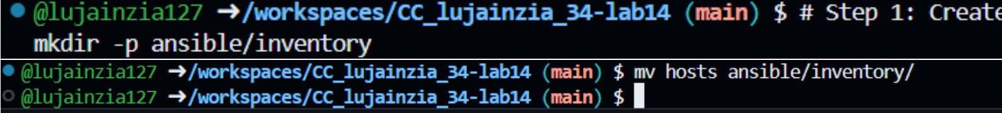
Test nginx group:
cd ansible
ansible nginx -m ping
Screenshot: task5_ansible_ping_nginx.png
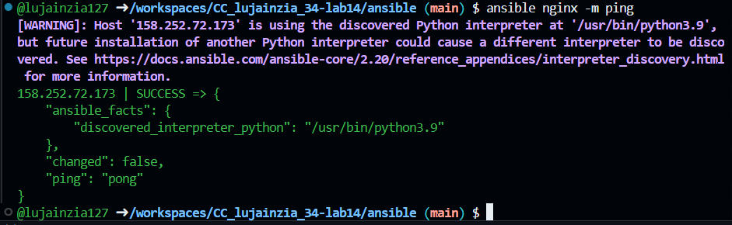
Task 6 Ansible-managed SSL certificates

Get public IP using IMDSv2:
# Add to playbook:
- name: Get IMDSv2 token
uri:
url: http://169.254.169.254/latest/api/token
method: PUT
headers:
X-aws-ec2-metadata-token-ttl-seconds: "21600"
return_content: yes
register: imds_token
Screenshot: task6_playbook_imdsv2.png
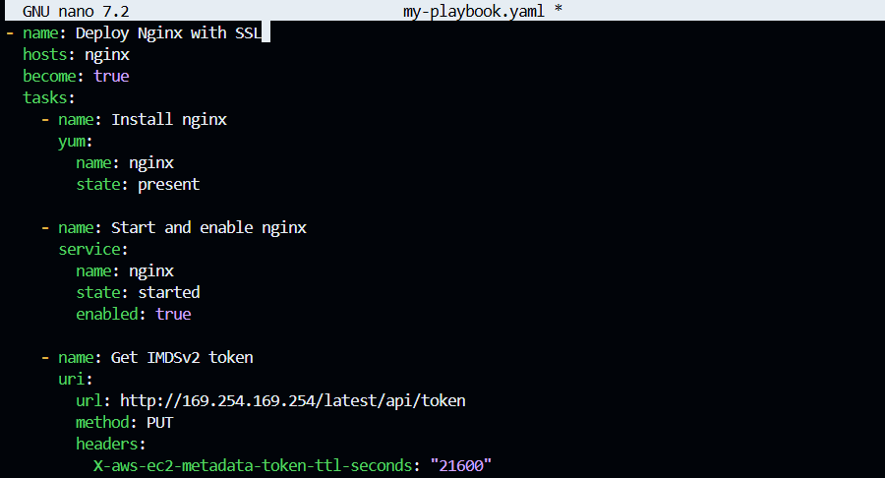
Generate SSL certificate:
- name: Generate private key
command: openssl genrsa -out /etc/ssl/private/selfsigned.key 2048

- name: Generate certificate
command: >
openssl req -new -x509 -key /etc/ssl/private/selfsigned.key
-out /etc/ssl/certs/selfsigned.crt -days 365
-subj "/CN={{ server_public_ip }}"
Screenshot: task6_playbook_ssl_tasks.png
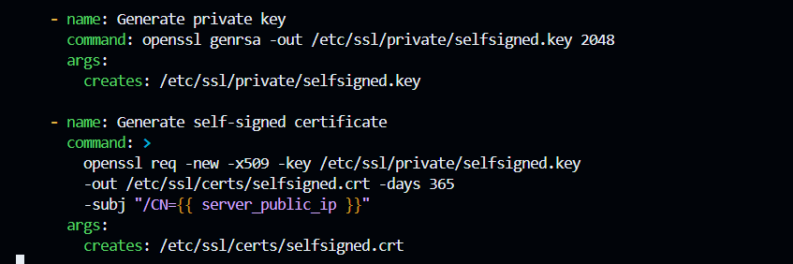
Run SSL playbook:
ansible-playbook my-playbook.yaml
Screenshot: task6_ansible_play_ssl.png
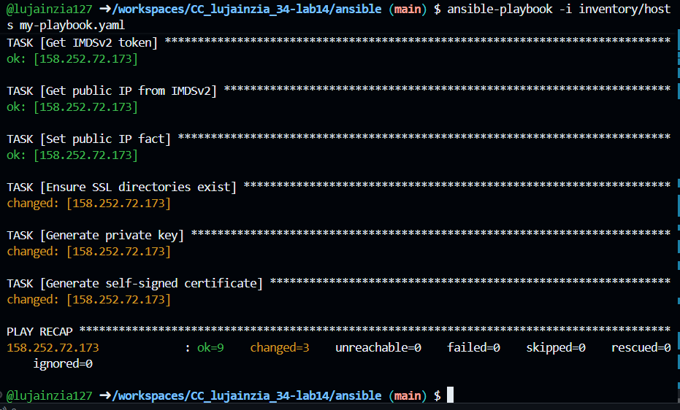
Verify certificates:
ansible nginx -m shell -a 'ls -la /etc/ssl/certs/selfsigned.crt'
Screenshot: task6_verify_ssl_files.png
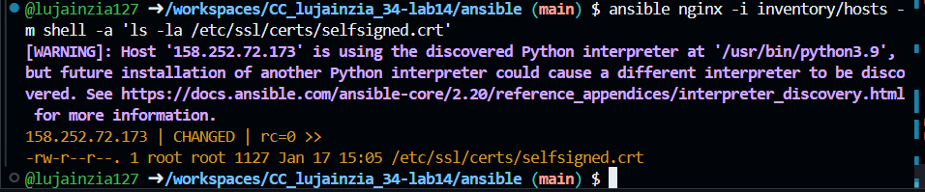
Task 7 PHP front-end deployment with templates

Create index.php:
touch index.php
Screenshot: task7_index_php.png

Create nginx.conf.j2 template:
touch nginx.conf.j2
Screenshot: task7_nginx_conf_template.png
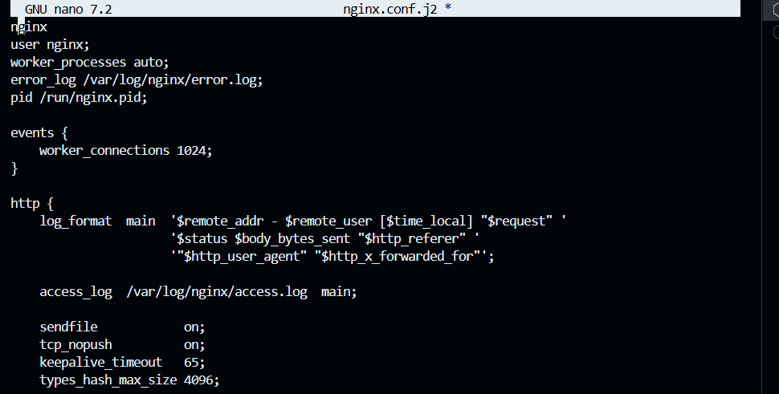
Update playbook for PHP:
- name: Install PHP
yum:
name:
- php-fpm
- php-curl
state: present
Screenshot: task7_playbook_php.png
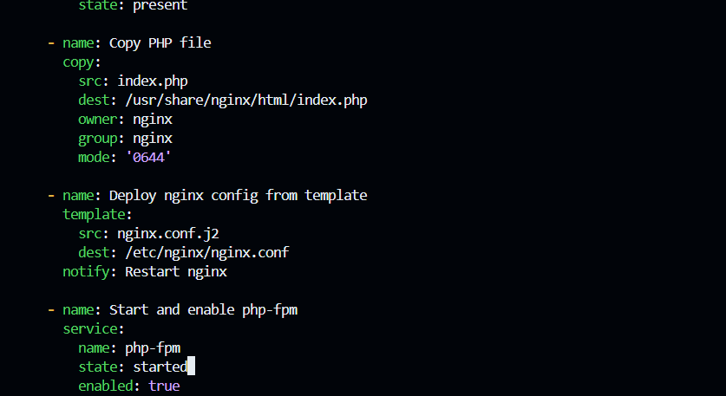
Run playbook:
ansible-playbook my-playbook.yaml
Screenshot: task7_ansible_play_php.png
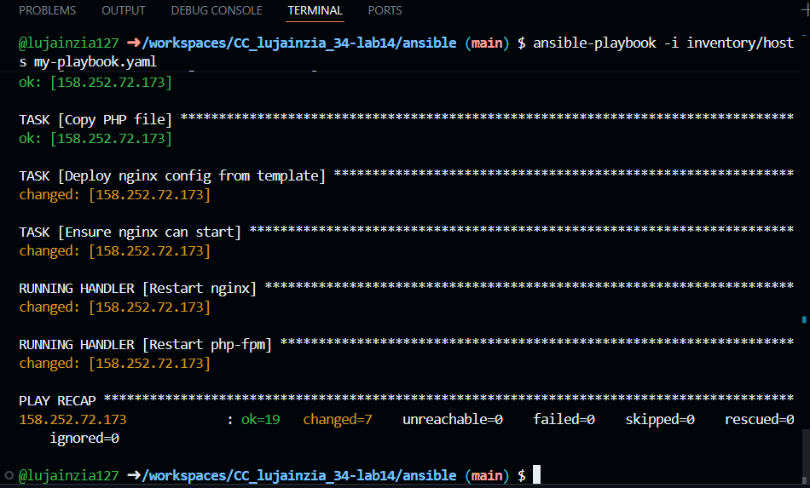
Test HTTPS with PHP:
# Open https://<instance-ip>
Screenshot: task7_php_https_browser.png
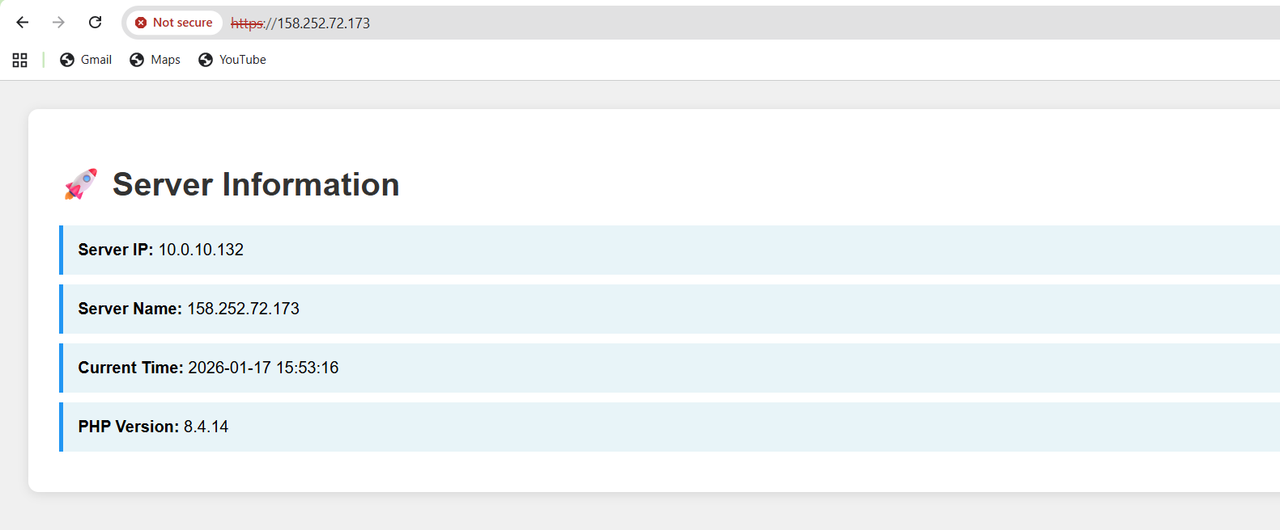
Task 8 Docker & Docker Compose provisioning via Ansible

Add Docker tasks to playbook:
- name: Install Docker
yum:
name: docker
state: present

- name: Start Docker
service:
name: docker
state: started
enabled: true
Screenshot: task8_playbook_docker.png
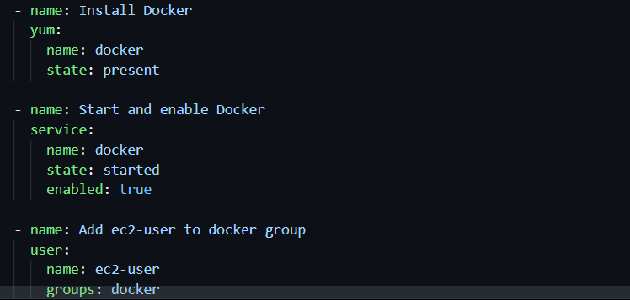
Install Docker Compose:
- name: Install Docker Compose
get_url:
url: https://github.com/docker/compose/releases/download/v2.20.0/docker-compose-linux-x86_64
dest: /usr/local/bin/docker-compose
mode: '0755'
Screenshot: task8_playbook_compose.png
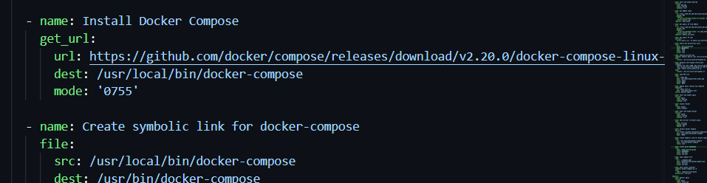
Run playbook:
ansible-playbook my-playbook.yaml
Screenshot: task8_ansible_play_docker.png
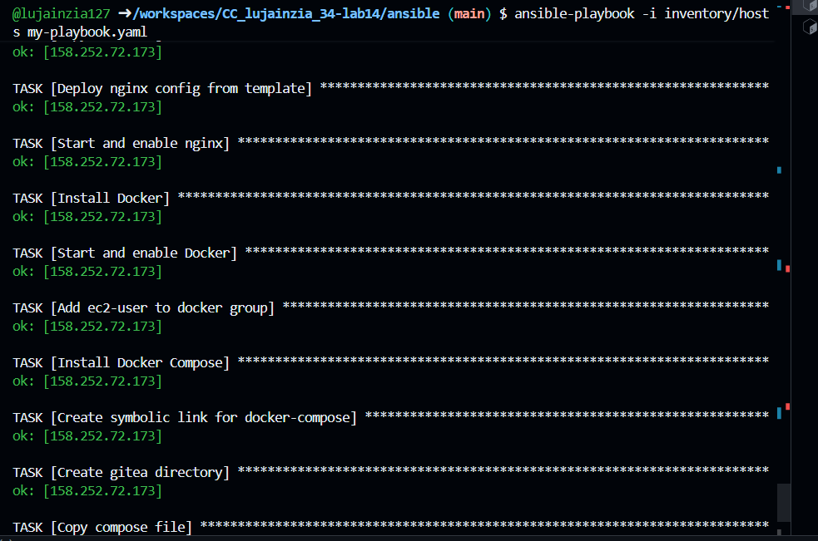
Verify Docker:
ansible nginx -m shell -a 'docker --version'
ansible nginx -m shell -a 'docker-compose --version'
Screenshot: task8_verify_docker.png
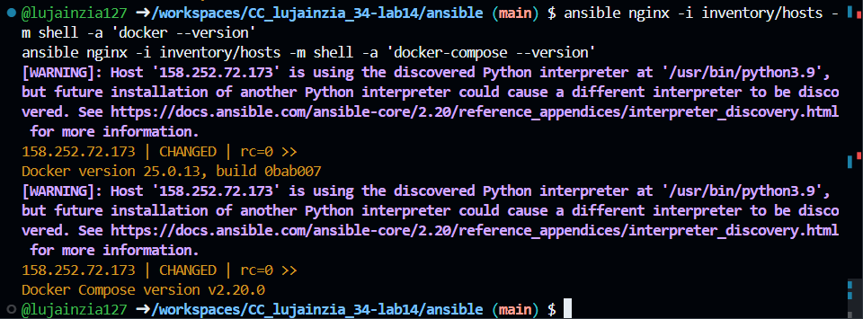
Task 9 Gitea Docker stack via Ansible + Terraform security group update

Create compose.yaml:
touch compose.yaml
Screenshot: task9_compose_yaml.png
Update security group in Terraform:
# Add port 3000 to security group
ingress {
from_port = 3000
to_port = 3000
protocol = "tcp"
cidr_blocks = ["0.0.0.0/0"]
}
Screenshot: task9_sg_port_3000.png
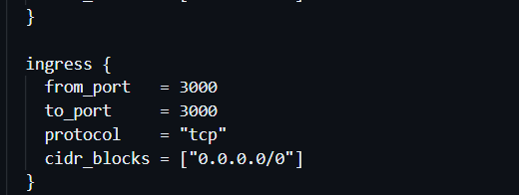
Apply Terraform:
terraform apply -auto-approve
Screenshot: task9_terraform_apply_sg.png
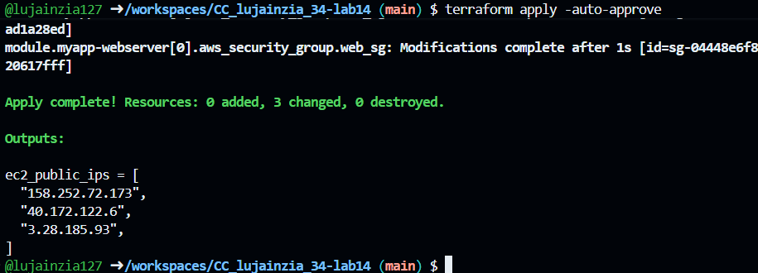
Deploy Gitea with Ansible:
- name: Copy compose file
copy:
src: compose.yaml
dest: /home/ec2-user/compose.yaml

- name: Start Gitea
command: docker-compose up -d
Screenshot: task9_playbook_gitea.png
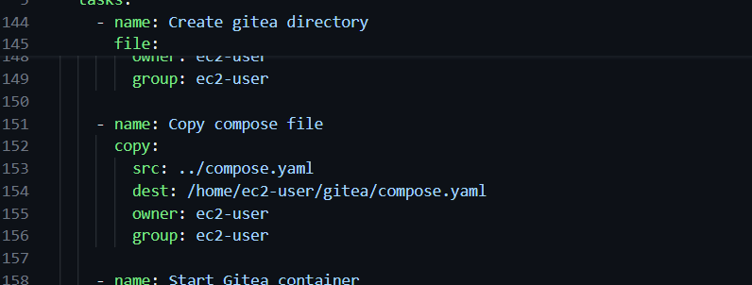
Run playbook:
ansible-playbook my-playbook.yaml
Screenshot: task9_ansible_play_gitea.png
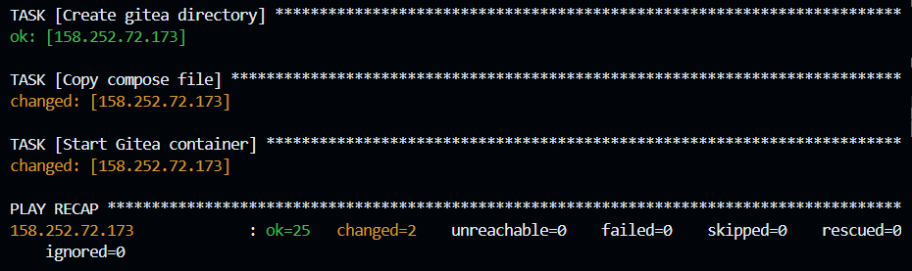
Test Gitea:
# Open http://<instance-ip>:3000
Screenshot: task9_gitea_browser.png
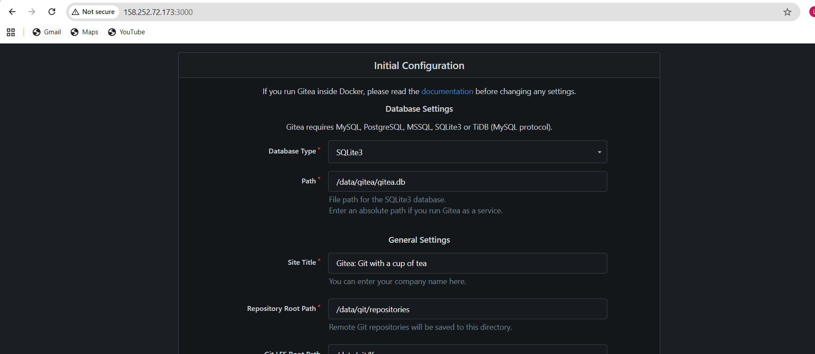
Task 10 Automating Ansible with Terraform (null_resource)

Add null_resource to main.tf:
resource "null_resource" "ansible_provision" {
depends_on = [module.myapp-webserver]

provisioner "local-exec" {
command = "ansible-playbook -i ansible/inventory/hosts ansible/my-playbook.yaml"
}
}
Screenshot: task10_main_tf_null_resource.png
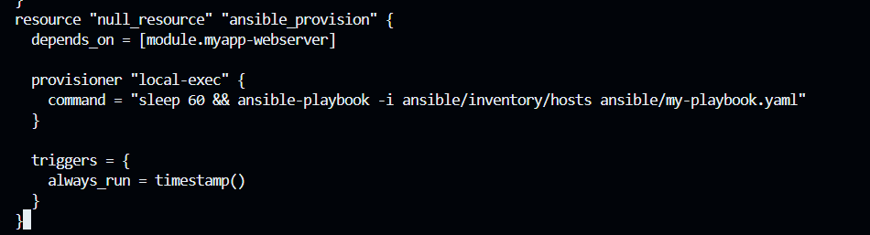
Apply Terraform:
terraform apply -auto-approve
Screenshot: task10_terraform_apply_ansible.png
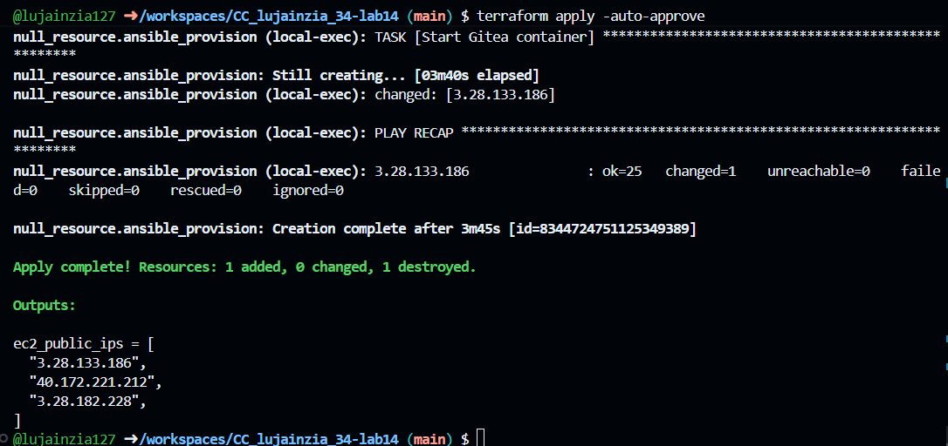

Verify automation:
# Check that Ansible ran automatically
Screenshot: task10_verify_automation.png
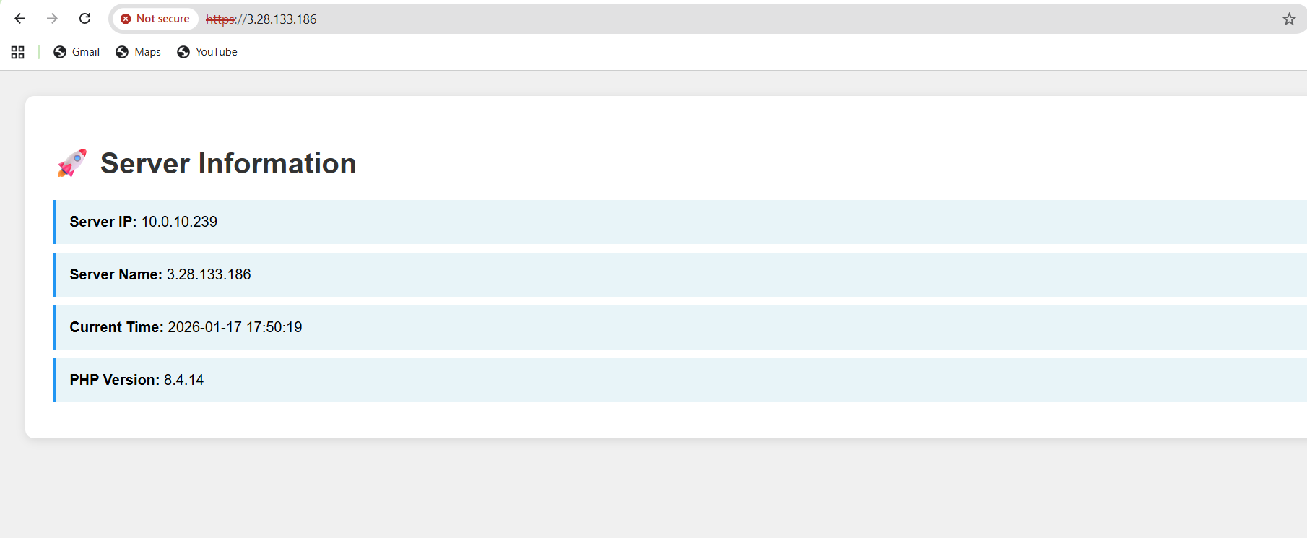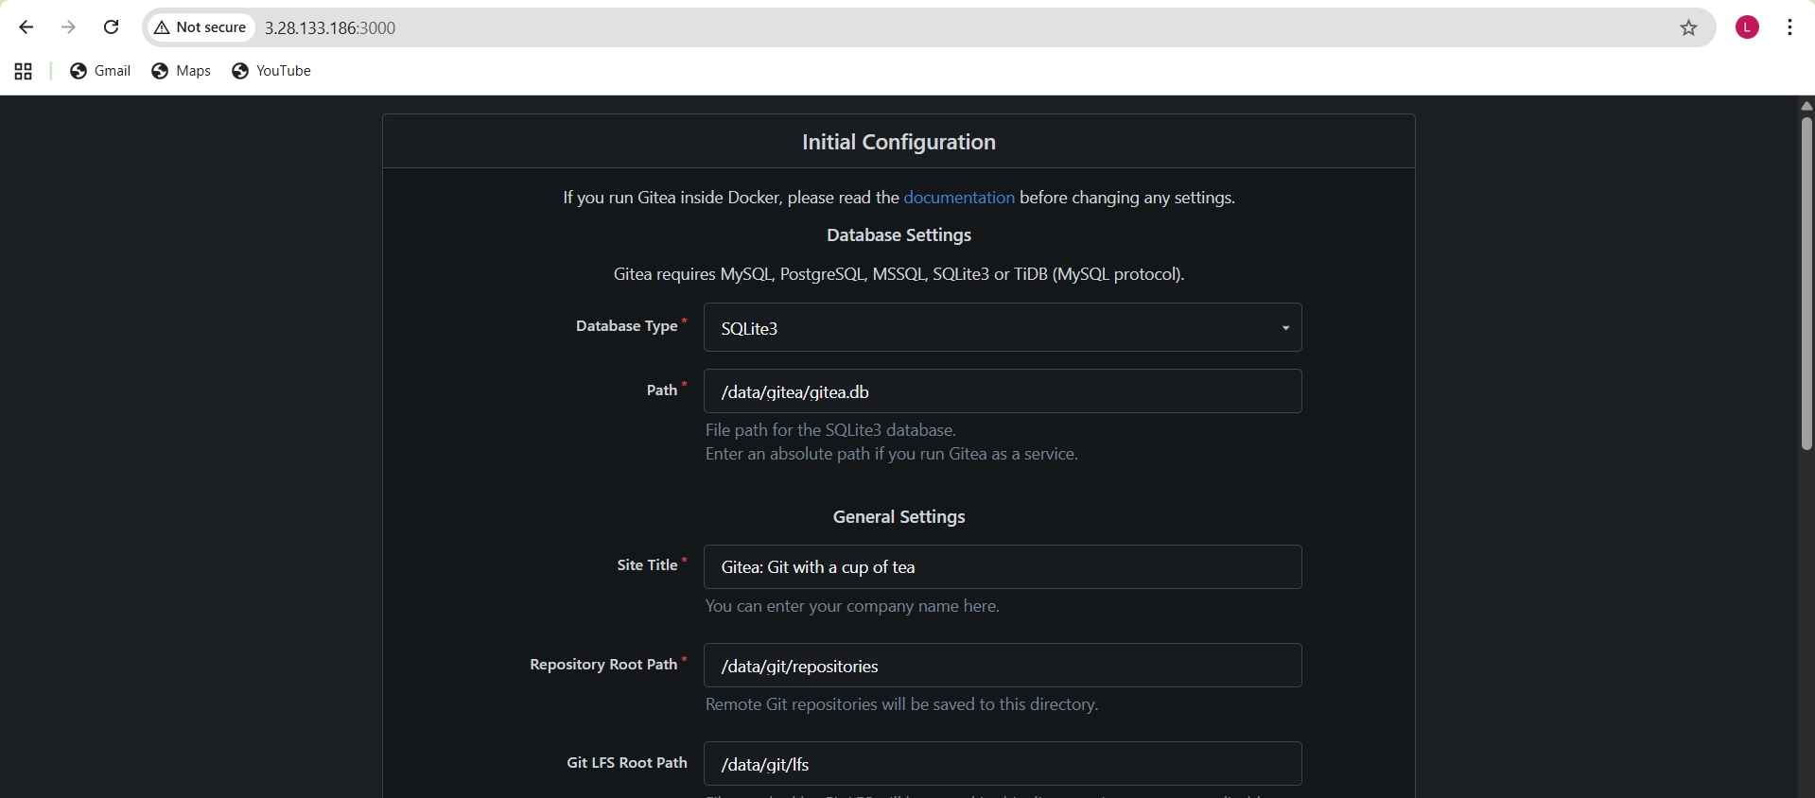
Task 11 Dynamic inventory with aws_ec2 plugin

Install boto3:
pipx inject ansible-core boto3 botocore
Screenshot: task11_install_boto3.png
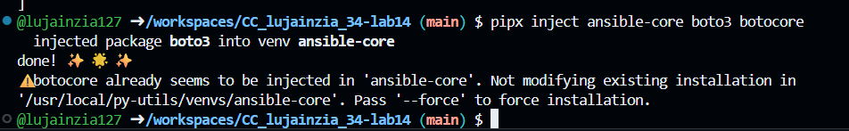
Create inventory_aws_ec2.yaml:
touch inventory_aws_ec2.yaml
Screenshot: task11_inventory_aws_ec2.png
Test dynamic inventory:
ansible-inventory -i inventory_aws_ec2.yaml --graph
Screenshot: task11_inventory_graph.png
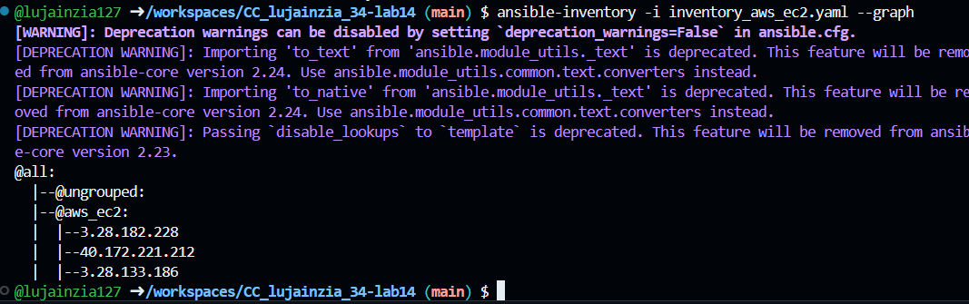
Use dynamic inventory:
ansible-playbook -i inventory_aws_ec2.yaml my-playbook.yaml
Screenshot: task11_ansible_play_dynamic.png
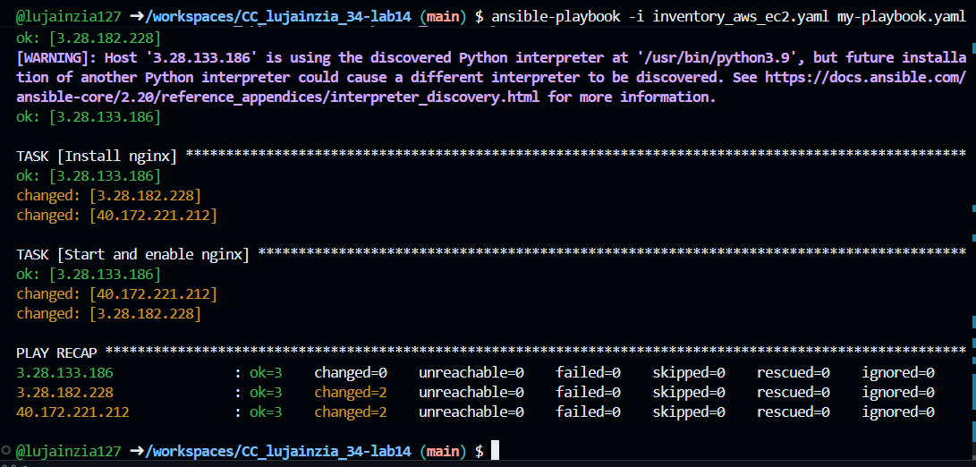
Task 12 Filtering EC2 instances by tags & instance type

Update inventory with filters:
# Add to inventory_aws_ec2.yaml:
filters:
tag:Environment: dev
instance-type: t3.micro

keyed_groups:
- key: tags.Environment
prefix: env
- key: instance_type
prefix: type
Screenshot: task12_inventory_filters.png
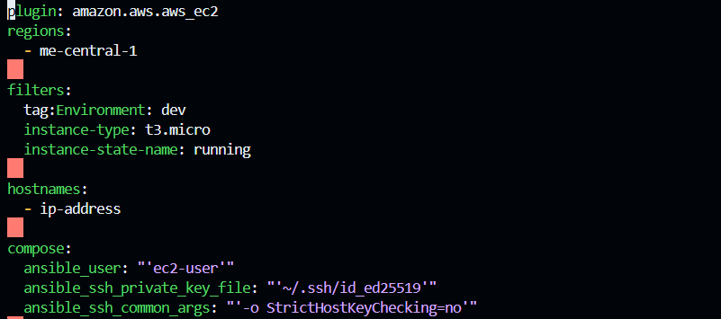
View grouped inventory:
ansible-inventory -i inventory_aws_ec2.yaml --graph
Screenshot: task12_inventory_groups.png
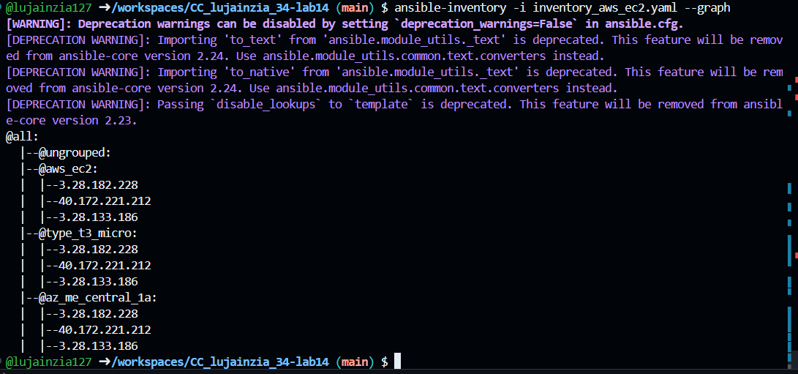
Target specific group:
ansible-playbook -i inventory_aws_ec2.yaml my-playbook.yaml -l env_dev
Screenshot: task12_ansible_play_limited.png
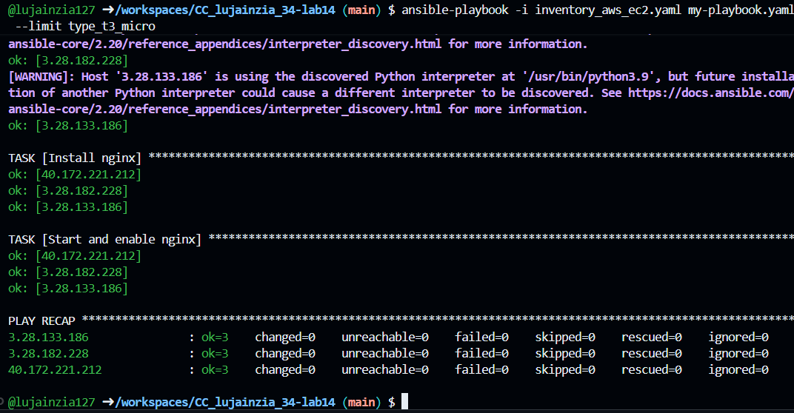
Task 13 Ansible roles: nginx, ssl, webapp

Scale down to 1 instance:
# Update main.tf: count = 1
terraform apply -auto-approve
Screenshot: task13_main_tf_single_dev.png
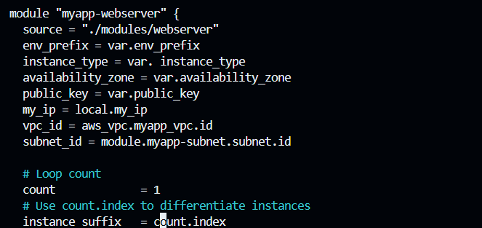
Create ansible directory structure:
mkdir -p ansible/{roles,inventory}
cd ansible
Screenshot: task13_ansible_structure_created.png
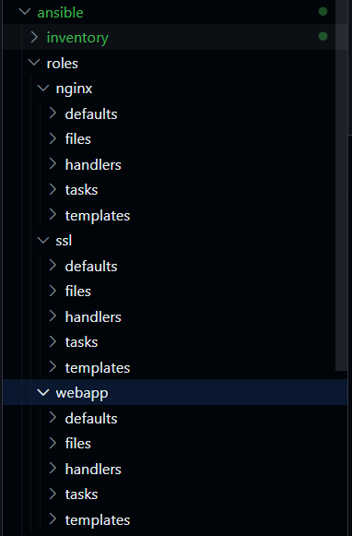
Create ansible.cfg:
touch ansible.cfg
Screenshot: task13_ansible_cfg_project.png
Create inventory/hosts:
touch inventory/hosts
Screenshot: task13_ansible_inventory_hosts.png
Create roles:
mkdir -p roles/{nginx,ssl,webapp}/{tasks,handlers,defaults,templates,files}
touch roles/nginx/tasks/main.yml
touch roles/nginx/handlers/main.yml
touch roles/ssl/tasks/main.yml
touch roles/ssl/defaults/main.yml
touch roles/webapp/tasks/main.yml
touch roles/webapp/handlers/main.yml
touch roles/webapp/defaults/main.yml
touch roles/webapp/templates/nginx.conf.j2
touch roles/webapp/files/index.php
Screenshot: task13_roles_created.png
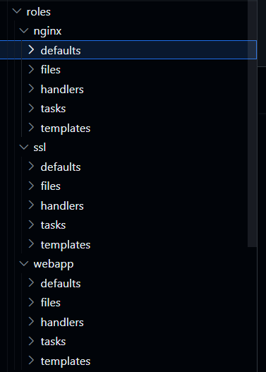
Create nginx role:
# roles/nginx/handlers/main.yml
Screenshot: task13_nginx_handlers_main.png
# roles/nginx/tasks/main.yml
Screenshot: task13_nginx_tasks_main.png

Test nginx role:
# Create my-playbook.yaml with nginx role
Screenshot: task13_my_playbook_nginx_only.png
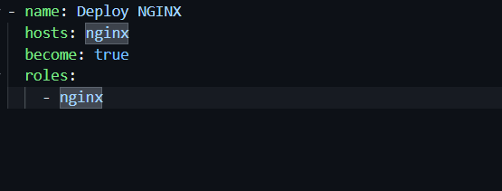
ansible-playbook -i inventory/hosts my-playbook.yaml
Screenshot: task13_ansible_play_nginx_only.png
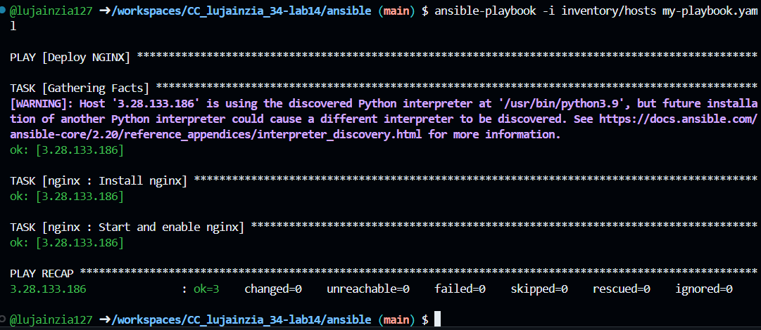
# Test in browser
Screenshot: task13_nginx_browser_roles.png
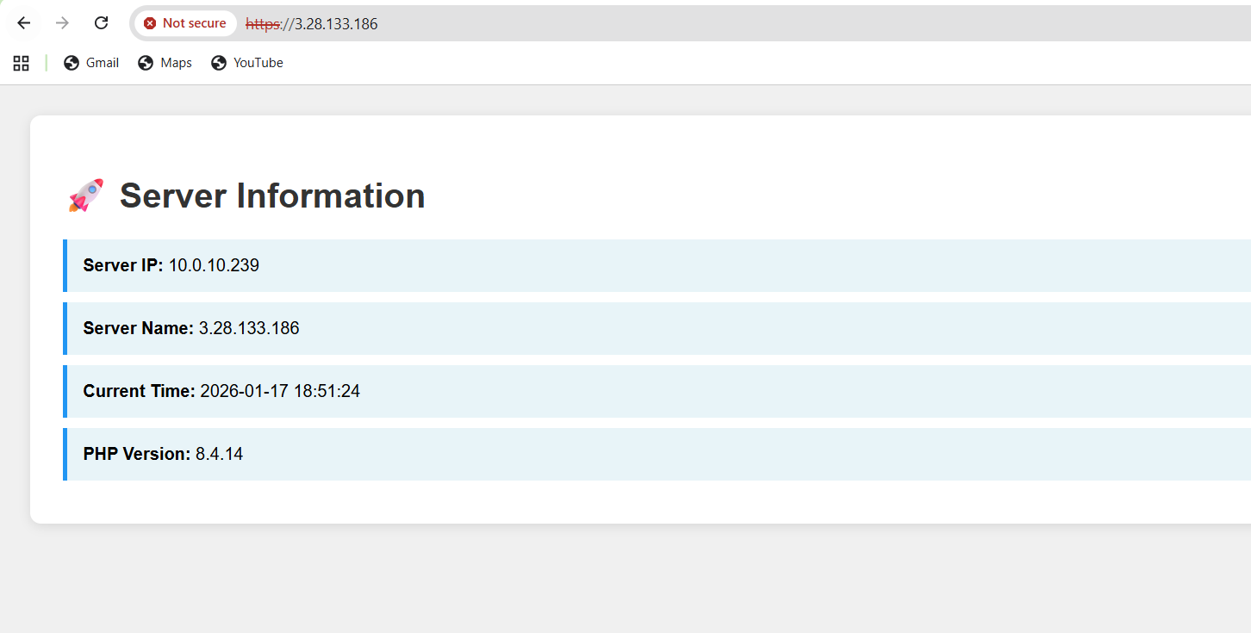

Create SSL role:
# roles/ssl/defaults/main.yml
Screenshot: task13_ssl_defaults_main.png
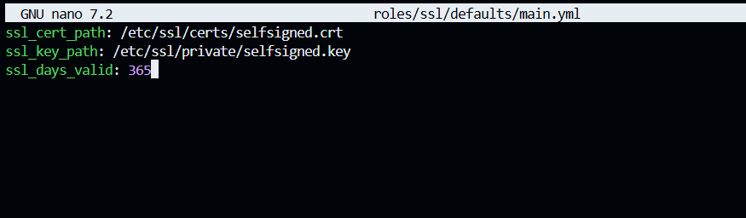
# roles/ssl/tasks/main.yml
Screenshot: task13_ssl_tasks_main.png
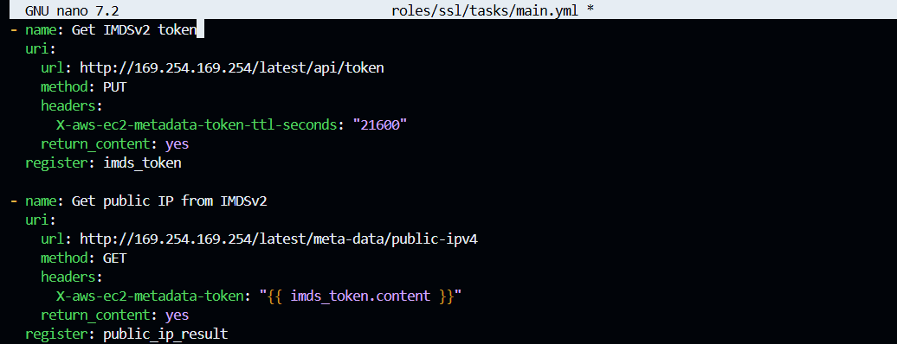
Create webapp role:
# roles/webapp/defaults/main.yml
Screenshot: task13_webapp_defaults_main.png
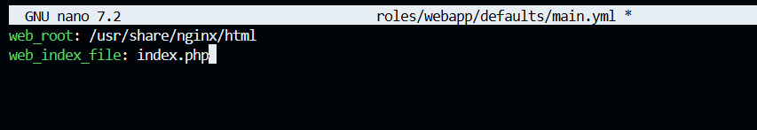
# roles/webapp/files/index.php
Screenshot: task13_webapp_files_index_php.png
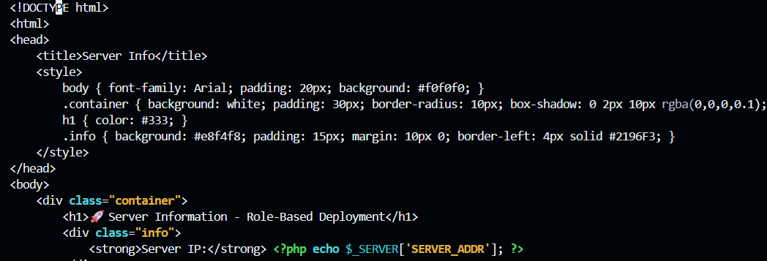
# roles/webapp/handlers/main.yml
Screenshot: task13_webapp_handlers_main.png
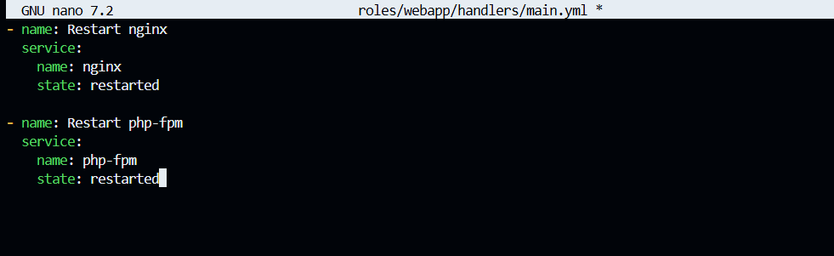

# roles/webapp/templates/nginx.conf.j2
Screenshot: task13_webapp_templates_nginx_conf.png
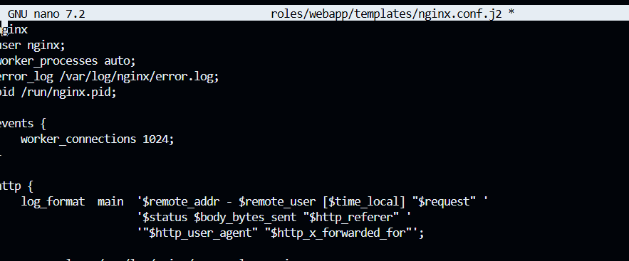
# roles/webapp/tasks/main.yml
Screenshot: task13_webapp_tasks_main.png
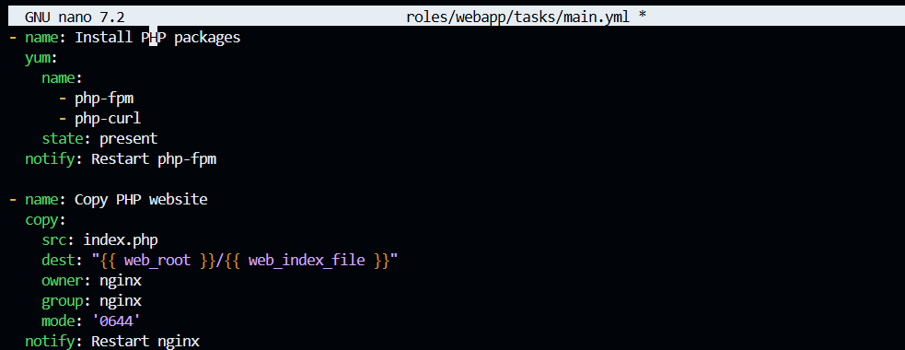

Final playbook with all roles:
# Update my-playbook.yaml
Screenshot: task13_my_playbook_roles.png
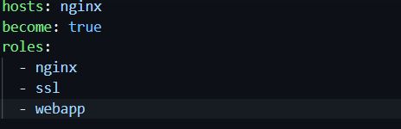
Run complete playbook:
ansible-playbook -i inventory/hosts my-playbook.yaml
Screenshot: task13_ansible_play_roles.png
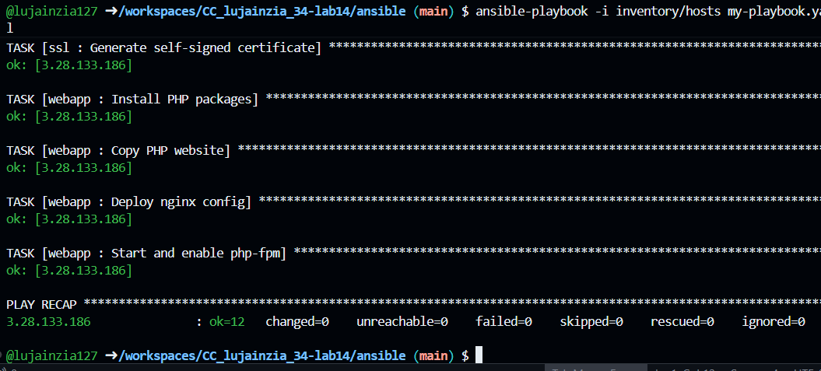
Test final deployment:
# Open https://<instance-ip>
Screenshot: task13_php_https_browser_roles.png
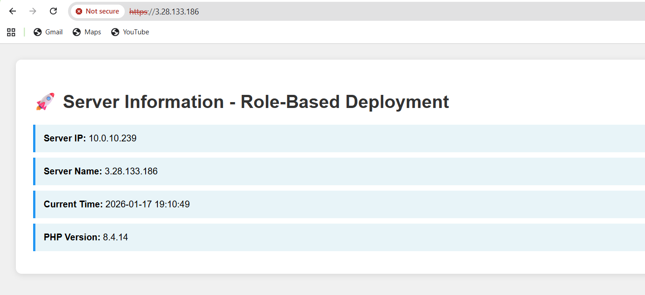
Cleanup

Destroy infrastructure:
terraform destroy -auto-approve
Screenshot: cleanup_terraform_destroy.png
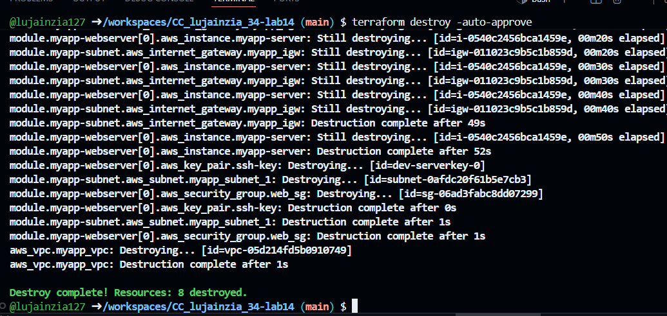

Verify state:
cat terraform.tfstate
Screenshot: cleanup_tfstate.png
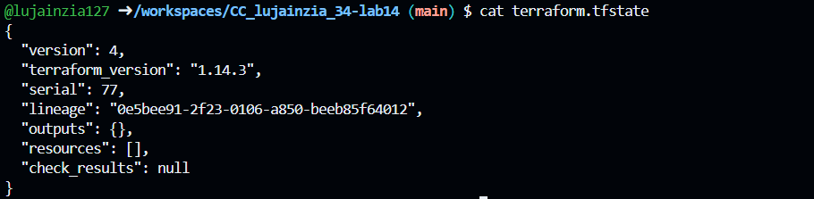
Confirm AWS console:
# Check EC2 console - no instances running
Screenshot: cleanup_aws_console.png
